SIMATS ENGINEERING
ASSESSMENT TOOL 2

COURSE NAME: Design and Analysis of Algorithms COURSE CODE: CSA0601

COURSE OUTCOME COVERED

CO2: Apply Brute Force technique to solve sorting, searching, Closest-Pair and Convex-Hull problems (BL1,BL2,BL3)

Assessment Tool Weightage: 20%

QUESTIONS: 10 Total Marks: 50

Annexure A

Scenario Based Assessment

Code of Conduct:

I _U.Prabhavathi/19247206_ (Name / Reg No) certify that this submission is my original work and that I have adhered to the guidelines specified for this assessment.
I understand that any violation of academic integrity rules will result in disciplinary action.
U.Pranhavathi
Signature of the student:

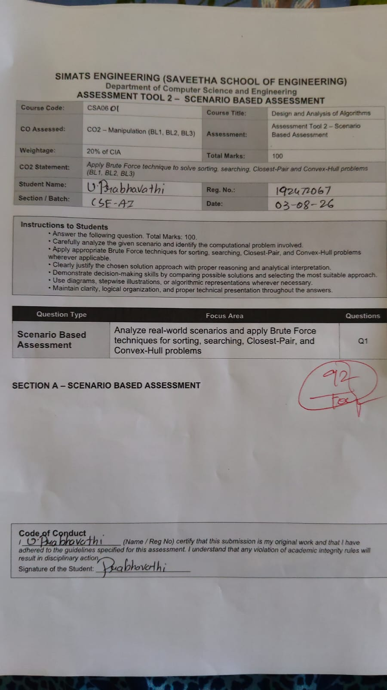
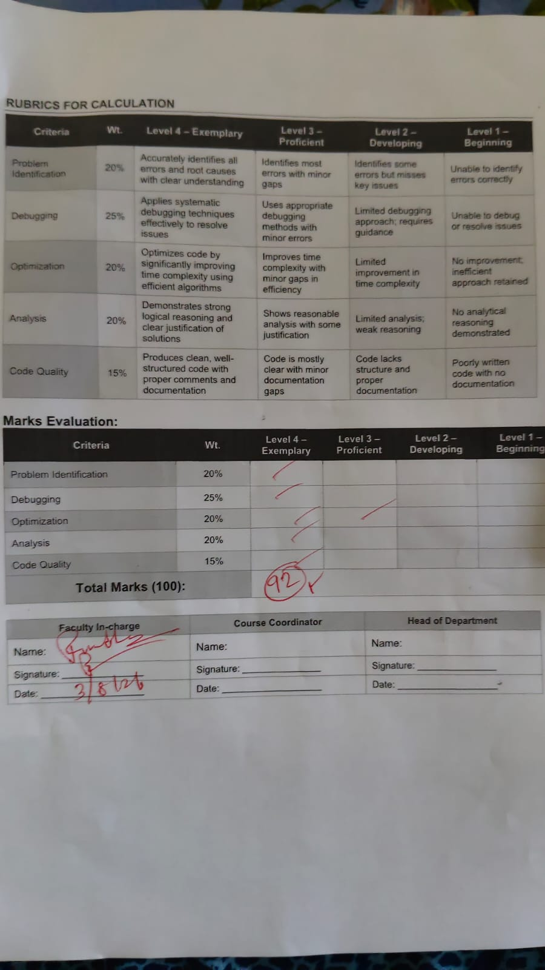

Annexure A

Scenario-Based Assessment

- Q96. An e-commerce system searches for product records stored in an unsorted list using Linear Search.
a) Explain how Linear Search operates in this system.
b) Analyze performance degradation with increasing data size.
c) Suggest improvements and justify.
Q97. A GPS tracking system evaluates distances between multiple vehicles to identify the closest pair using brute-force computation.
a) Explain how all possible pairs are evaluated.
b) Derive the time complexity.
c) Discuss scalability challenges.
Q98. A programming tool searches for specific syntax patterns in large code repositories using brute-force string matching.
a) Explain how the matching process works.
b) Analyze its time complexity.
c) Justify the need for optimized algorithms.
Q99. A banking system maintains sorted customer IDs for quick lookup using Binary Search, but frequent updates disrupt the order.
a) Explain how Binary Search works.
b) Analyze the effect of unsorted data on performance.
c) Discuss the importance of maintaining sorted order.
Q100. A robotics system processes obstacle coordinates to determine boundaries using brute-force convex hull computation.
a) Explain how convex hull is determined.
b) Analyze the time complexity.
c) Discuss scalability concerns.

Q96. An e-commerce system searches for product records stored in an unsorted list using Linear Search.

a) Explain how Linear Search operates in this system.
Linear Search is the simplest searching technique used to find an element in an unsorted list. In an e-commerce system, products may be stored in an array or list without any particular order. When a customer searches for a product, the system compares the search key (such as Product ID or Product Name) with each product record one by one until a match is found.

Working Steps
- Start from the first product.
- Compare the product ID with the required product.
- If they match, return the product details.
- Otherwise, move to the next product.
- Repeat until the product is found or the list ends.
- If the last product is checked and no match is found, display "Product Not Found."

Example
Products:020
Position | Product ID
1 | 101
2 | 215
3 | 324
4 | 456
5 | 587
Search Product = 456
Comparisons:
- 101 ≠ 456
- 215 ≠ 456
- 324 ≠ 456
- 456 = Found
Total Comparisons = 4

Algorithm
Step 1: Start
Step 2: Read Product ID
Step 3: Compare with first record
Step 4: If match found, display record
Step 5: Else move to next record
Step 6: Repeat until last record
Step 7: If not found, display "Product Not Found"
Step 8: Stop

b) Analyze performance degradation with increasing data size.
The performance of Linear Search depends on the number of products.
For a small product database, searching is quick. As more products are added, the number of comparisons increases. Therefore, search time also increases.

Time Complexity
Case | Complexity
Best Case | O(1)
Average Case | O(n)
Worst Case | O(n)

Performance Analysis
Number of Products | Maximum Comparisons
100 | 100
1,000 | 1,000
10,000 | 10,000
100,000 | 100,000
1,000,000 | 1,000,000
Thus, Linear Search is inefficient for very large databases because every additional product increases the search time.

c) Suggest improvements and justify.

Improvement 1: Binary Search
- Sort the products first.
- Search time becomes O(log n).

Improvement 2: Hash Table
- Store products using Product ID as key.
- Average search time becomes O(1).

Improvement 3: Database Indexing
- Use B-Tree or B+ Tree indexing.
- Faster searching even with millions of records.

Justification
- Reduces search time.
- Improves customer experience.
- Handles large product databases efficiently.
- Supports faster online shopping.

Q97. A GPS tracking system evaluates distances between multiple vehicles to identify the closest pair using brute-force computation.

a) Explain how all possible pairs are evaluated.
In the brute-force closest pair algorithm, every vehicle is compared with every other vehicle.
For each pair:
- Calculate the Euclidean distance.
- Store the minimum distance.
- Continue until every possible pair has been checked.

Distance Formula
Distance=(x2−x1)2+(y2−y1)2Distance=\sqrt{(x_2-x_1)^2+(y_2-y_1)^2}Distance=(x2​−x1​)2+(y2​−y1​)2​

Example
Vehicles
A(1,2)
B(3,5)
C(6,7)
D(8,9)
Pairs checked:
- A-B
- A-C
- A-D
- B-C
- B-D
- C-D
Each distance is calculated.
The pair with the smallest distance becomes the closest pair.

b) Derive the time complexity.
If there are n vehicles,
Total possible pairs:
n(n−1)2\frac{n(n-1)}{2}2n(n−1)​
Each pair requires one distance calculation.
Therefore,
T(n)=n(n−1)2T(n)=\frac{n(n-1)}{2}T(n)=2n(n−1)​
Ignoring constants,
Time Complexity = O(n²)

Example
Vehicles | Pairs
5 | 10
10 | 45
100 | 4,950
1,000 | 499,500
As the number of vehicles increases, computations increase rapidly.

c) Discuss scalability challenges.

Problems
- High execution time.
- Large CPU utilization.
- Increased memory usage.
- Unsuitable for real-time GPS tracking.
- Delayed vehicle monitoring.

Better Solution
Use Divide and Conquer Closest Pair Algorithm.
Complexity:
O(n log n)
Benefits:
- Faster processing.
- Suitable for thousands of vehicles.
- Better scalability.

Q98. A programming tool searches for specific syntax patterns in large code repositories using brute-force string matching.

a) Explain how the matching process works.
Brute-force string matching compares the pattern with every possible position in the text.
If characters match completely, the pattern is found.
Otherwise, move the pattern by one position and continue searching.

Example
Text:
int main()
{
return 0;
}
Pattern:
return
Comparison starts from the first character of the text.
The algorithm shifts one character at a time until "return" matches.

b) Analyze its time complexity.
Let
n = length of text
m = length of pattern
Worst-case comparisons:
(n−m+1)×m(n-m+1)\times m(n−m+1)×m
Therefore,
Worst Case = O(nm)

Example
Text Length = 5000
Pattern Length = 20
Comparisons:
(5000−20+1)×20(5000-20+1)\times20(5000−20+1)×20
≈ 99,620 comparisons.

c) Justify the need for optimized algorithms.
Brute-force searching is inefficient because:
- Too many comparisons.
- Slow for large source code.
- Poor performance with repeated searches.

Better Algorithms
KMP Algorithm
- Complexity: O(n+m)
Boyer-Moore
- Skips unnecessary comparisons.
Rabin-Karp
- Uses hashing.
- Suitable for multiple patterns.
Benefits:
- Faster searching.
- Reduced CPU usage.
- Better for IDEs and compilers.

Q99. A banking system maintains sorted customer IDs for quick lookup using Binary Search, but frequent updates disrupt the order.

a) Explain how Binary Search works.
Binary Search repeatedly divides the sorted list into two halves.
Steps:
- Find the middle element.
- Compare it with the target.
- If equal, stop.
- If target is smaller, search the left half.
- If larger, search the right half.
- Repeat until found.

Example
Customer IDs
101 205 310 415 520 640 755
Search = 520
Middle = 415
520 > 415
Search right half
Middle = 640
520 < 640
Search left
520 Found.
Only three comparisons are required.

b) Analyze the effect of unsorted data on performance.
Binary Search requires sorted data.
If records become unsorted:
Example
101 520 205 415 310
Searching for 310 may fail because Binary Search incorrectly eliminates half of the data.
Therefore:
- Incorrect search results.
- Search failure.
- Binary Search becomes unusable.
Time Complexity
Sorted Data = O(log n)
Unsorted Data = Binary Search cannot be correctly applied.

c) Discuss the importance of maintaining sorted order.
Maintaining sorted order ensures:
- Correct search results.
- Fast searching.
- Efficient customer record management.
- Reduced transaction processing time.
- Better database performance.
Banks usually use:
- Balanced Binary Search Trees
- B-Trees
- B+ Trees
These structures maintain order while allowing frequent insertions and deletions.

Q100. A robotics system processes obstacle coordinates to determine boundaries using brute-force convex hull computation.

a) Explain how convex hull is determined.
A Convex Hull is the smallest convex polygon that contains all given points.

Brute-force Method
- Select every pair of points.
- Draw a line joining them.
- Check every remaining point.
- If all points lie on one side of the line, the edge belongs to the convex hull.
- Repeat for all point pairs.
- Connect all valid edges to obtain the convex hull.

Example
Points:
A, B, C, D, E
After checking all pairs,
Hull = A → B → D → E → A
Point C lies inside the polygon.

b) Analyze the time complexity.
For n points:
- Number of pairs = O(n²)
- Checking all other points for each pair = O(n)
Total complexity:
O(n2)×O(n)=O(n3)O(n^2)\times O(n)=O(n^3)O(n2)×O(n)=O(n3)

Example
Points | Operations
10 | ≈1,000
100 | ≈1,000,000
1,000 | ≈1,000,000,000
Execution time increases rapidly as the number of points grows.

c) Discuss scalability concerns.

Challenges
- Very high execution time.
- Large memory consumption.
- Not suitable for real-time robotics.
- Delays obstacle detection.
- Slower path planning.

Efficient Alternatives
Algorithm | Time Complexity
Brute Force | O(n³)
Graham Scan | O(n log n)
QuickHull | Average O(n log n)
Jarvis March | O(nh)

Advantages of Optimized Algorithms
- Faster obstacle detection.
- Better real-time navigation.
- Lower CPU usage.
- Suitable for autonomous robots.
- Handles large datasets efficiently.
These expanded answers are appropriate for 10-mark university exam questions, covering definitions, working, examples, algorithms, time complexities, analysis, and conclusions.

RUBRICS FOR CALCULATION

Criteria | Weightage | Level 4 – Exemplary | Level 3 – Proficient | Level 2 – Developing | Level 1 – Beginning
Problem Understanding & Context Analysis | 25 | Thoroughly understands the scenario with accurate interpretation of all requirements | Clearly understands the scenario with minor gaps | Basic understanding; some aspects of the scenario unclear | Poor understanding or misinterpretation of the scenario
Application of Concepts | 30 | Applies appropriate concepts effectively to solve complex real-world problems | Applies relevant concepts correctly with minor errors | Applies basic concepts but with limited accuracy | Fails to apply appropriate concepts
Analytical & Decision-Making Skills | 20 | Demonstrates strong analysis and selects optimal solutions with justification | Good analysis with reasonable solutions | Limited analysis; solutions lack justification | Poor or no analysis; incorrect decisions
Solution Design & Approach | 15 | Well-structured, innovative, and feasible solution approach | Logical and structured solution with minor gaps | Basic solution with limited structure or feasibility | Unclear or incorrect solution approach
Clarity, Justification & Presentation | 10 | Clear, well-justified explanation with strong reasoning | Clear explanation with some justification | Limited clarity and weak justification | Poorly explained with no justification

